Home Assignment 2
submitted by: Matan Dan On
Q. 1: 1. All the movies whose rank is at least 9.
a. Using “rank” as a name of a column in MySql is problematic. Explain why and explain how you cope with it.
(Hint: There are 49,573 movies whose rank is at least 5. Check your query by adapting it to this value and see that you get the same result.)

A.1:
- According to the MySQL documentation of keywords and reserved words, using ‘rank’ as a column name is problematic as it also serves as a keyword.
2 possible fixes to this limitation are:
- to wrap the column name in backsticks (as displayed in the query adjusted for the hint).
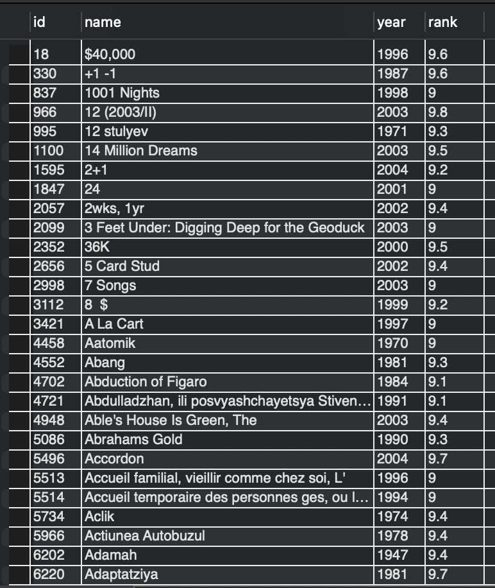
- Specify ‘rank’ refers to a column from a table by adding the table name before the keyword as displayed in the query.

Query: SELECT * FROM movies
WHERE movies.rank >=9;
Rows returned: 1353

Adjusted query for movies with rank
Higher than 5:
Query: SELECT * FROM.movies
WHERE `rank` >=5;

Rows returned: 49,573
Q. 2: All the different role names that include the string ‘him’
i. Take care of being case insensitive
ii. Note that the same role might appear in multiple movies, yet should only appear once in the results (Hint: There are 46,686 roles that contain the string ‘her’. Check your query by adapting it to this value and see that you get the same result.)
iii. Do you find the role name ‘Himself’ appropriate? To which problems it might lead? Explain why.
iv. Suggest a way to improve the returned list.
A. 2:
Part 1: I made sure the query was case insensitive by using lower() in the where statement.
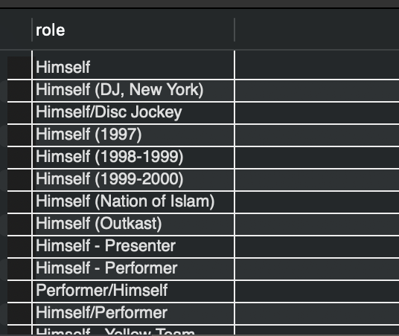
part 2: To prevent the same role appearing multiple times, I selected only distinct roles.
Query:
select distinct `role` from imdb_ijs.roles
where lower(`role`) like '%him%';

Rows returned: 15,524

Part 3: I think the role name ‘himself’ isn’t suitable as it doesn’t supply any information about who is portrayed, moreover several ‘himself’ portrayals may still serve different roles. I think it may lead to problems when filtering out unique roles since some actors portray themselves in different movies.
Part 4: To bridge this gap, I chose to create a unified column using the format “actor_name as himself” for an easy link by selecting the corresponding columns from their respective tables and filtering based on ID as a key. On top of that I chose to select and filter the name column of corresponding movies for some added context.

Query:
select a.id as actor_id,
concat(a.first_name,' ', a.last_name,' as ', r.role) as 'actor/role',
m.name
from roles as r, actors as a, movies as m
where r.actor_id = a.id
and r.movie_id = m.id
and lower(r.`role`) LIKE '%himself%'
order by a.id;

Rows returned: 119,997
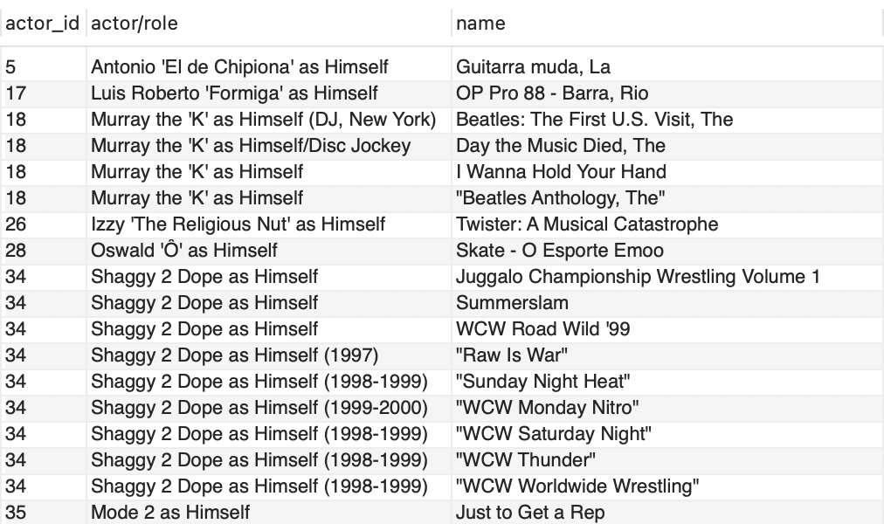

Q.3: All movies whose name is longer than 95 characters, ordered by length
a. Explain the prevalence of names in each length. Why is certain length much more common than the others?
b. Bonus: Suggest a way to identify some of the problematic names and implement it.
A.3:
a. I used length() to measure the length of movie names for filtration and ordering, besides that I also added the name length column to check for name length prevalence.
For name length of 97-99 is seemingly a single movie from 1900 registered in 4 installments. For movies with a name length of 100, many seem to be in foreign languages (mainly German, French and Spanish).
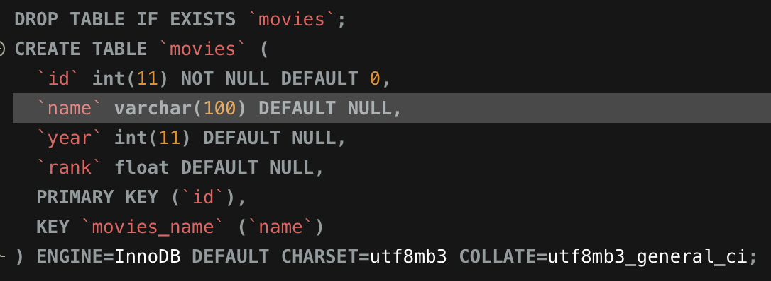
The most prevalent name length above 95 is 100 characters. As can be seen in the IMDB database creation script, this is caused by the character limit being set to 100, resulting in longer movie names being cut off at the hundredth character.

Query:
select *, length(name) as name_length
from movies
where length(name)>95
order by length(name) desc;

Rows returned: 104 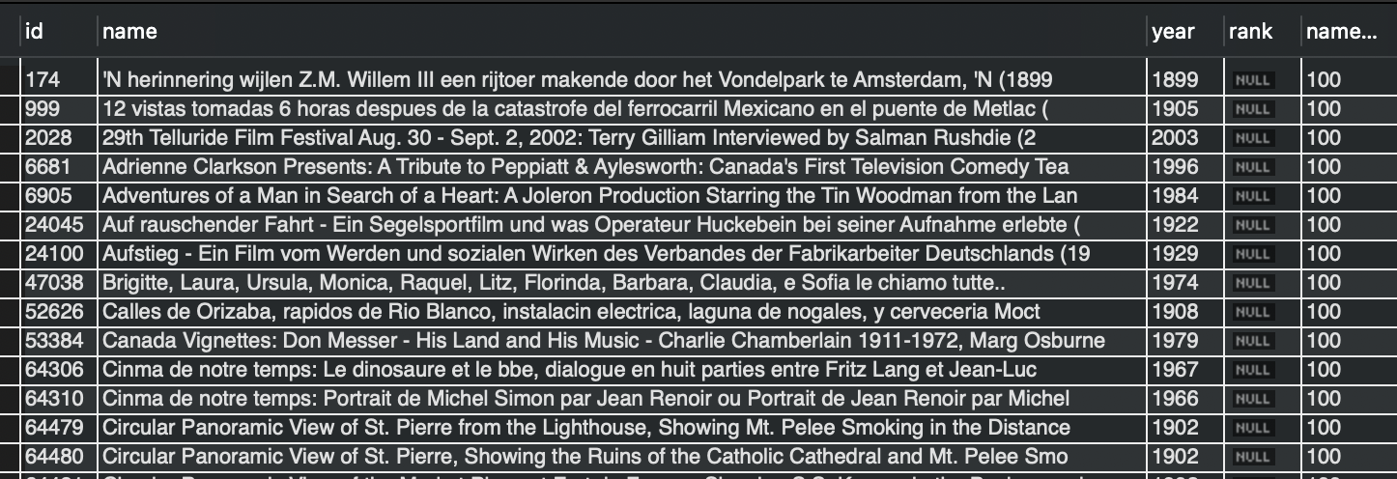

b. One common trait of incomplete names (due to supposed character limit) is that they end with either an open parentheses, at times there is content and at times not.
To identify such problematic names I chose to filter out movie names that contain an opening parentheses, then use right() to filter out names with unclosed parentheses which would point to an incomplete name.
Query:
select * from movies
where length(name) = 100
and name like ‘%(%’
and right(`name`,1) != ')';

rows returned: 34
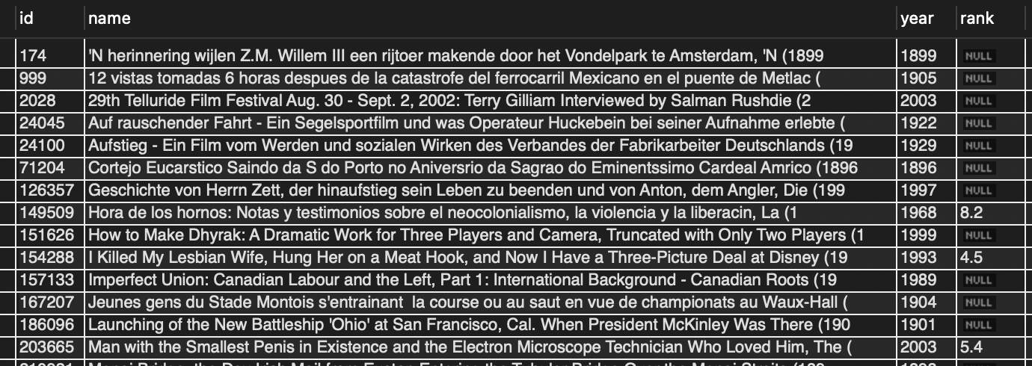

Q. 4: Find at least 3 first names in the actors table that are most likely to be mistakes. There are many ways to make mistakes so we are liberal and will accept any justified answer.
i. Explain how you found each of the names
ii. Suggest a possible cause of the mistake
iii. Suggest a way that would prevent the problem in the first place or identify it afterwards. Bonus: Find mistakes where it is not easy to do so.
A.4:
Below are the query and likely mistakes I found:
select first_name, last_name from actors
where first_name regexp '[^\\p{L} ()''.0-9-]'
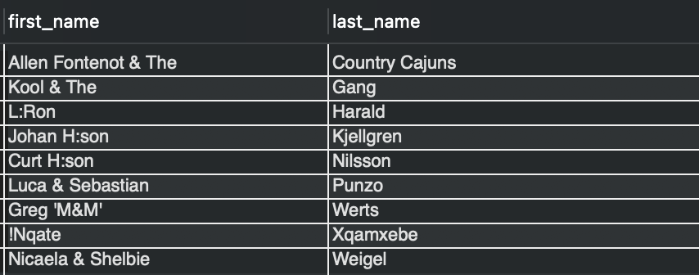
or first_name like ' %and%';

Rows returned: 9
After googling each one, I concluded that names using the character ‘&’ are likely either a band, or a pair of twins. In the case of twins, I believe this conclusion justifies classifying such names as mistakes, since they don’t credit both actors individually.
(Note: the names containing an exclamation point and colons aren’t mistakes, but may be in the future).
I think such mistakes may arise from either from lumping two actors together when manually crediting a movie because of laziness or for the sake of row count reduction. Moreover, such mistakes may arise from automated parsing errors if IMDB scrubs data from text files – for example movie credits for a single role played by both twins.
I think this mistake could have been prevented in the first place if the use of Ampersands (and perhaps also the word ‘and’) was monitored by a human or even by a program checking if the name refers to a single entity, which can in most cases be determined with a simple google search. Based on the program’s/manual search, such mistakes can be split into 2 rows.
To easily detect and verify suspicious names, I suggest the above regexp pattern, which will detect any name not containing any letter character from any language, parentheses, quotation marks, dots, numbers or dashes.
However, note this isn’t a perfect solution considering the pattern also flagged 4 names which turned out not to be mistakes..

